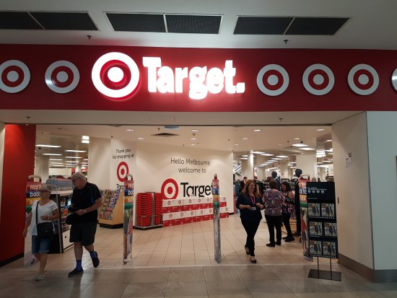

 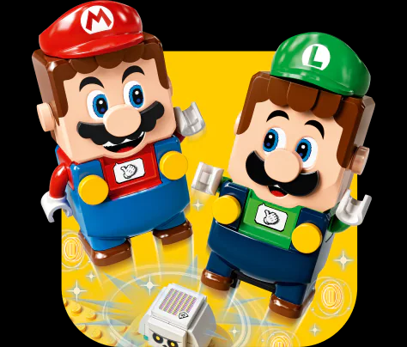

**Project Name- Target Australia**

**Description:**

Target Australia is a [department store](https://en.wikipedia.org/wiki/Department_store) chain owned by Australian retail conglomerate [Wesfarmers](https://en.wikipedia.org/wiki/Wesfarmers). Target stocks clothing, cosmetics, home wares, electronics, books, and toys selling both in-store and online. The company's head office is located in the [Melbourne](https://en.wikipedia.org/wiki/Melbourne) suburb of [Williams Landing](https://en.wikipedia.org/wiki/Williams_Landing), and opened in 2018.

**Goals:**

1. **Signup/login- Full name, Last name, Email, Password, Contact**
2. **Homepage- Logo, Search Bar, Icons (Wishlist, Add to cart), Filter, Images**
3. **Listing page- Images (name and prices), Details page, Deals, Social Media links**
4. **Payment Gateway- Payment Method**

**Mission and Vision Statement:**

“Target is an iconic Australian retailer dedicated to making fashion, style and quality affordable for the whole family.”

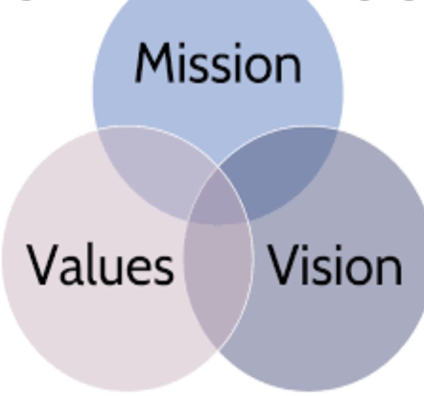

**Values:** Target core values include “**great shopping, celebrating diversity and inclusion, community engagement, and ethics at work.”** The values create a strong Target culture that ensures the company is always prepared and motivated to advance towards its vision.

***Prepared by: Deepika***